**Checks and Questions FBB-BGan**

**Questions**

* What is the terminal manufacturer and model? (Furuno=JRC for Firmware)
* What is the Firmware version used?
* What is the Launchpad version (if Launchpad is used)?
* Please identify your mobile (Card ICCID, IMSI, MSISDN)?
* In which country or region are you located?
* Is the current GPS Position up-to-date?
* Is your antenna signal strong and stable? How many bars?
* What kind of connection are you using (Background, Streaming, etc.)?
* Which operating system is used on the PC?
* Is there any device used between the terminal and the PC? If yes, what kind of device?
* What are the APN you tried to use?
* What is the service used? (username)
* Which interface is used (Ethernet, USB, WIFI, Bluetooth)?
* Did the terminal work before?
* Since when did the service stop working?
* What is the error code or error message?

**Checks**

* Check Mobile status in The Source, BSS, MMI (Radius).
  + 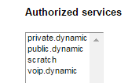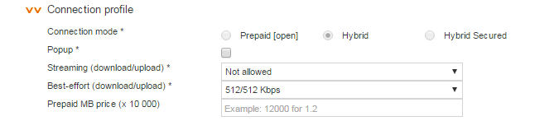If the card is not active in BSS > Admin Team
* Check Filter in the MMI.
* Firewall > Traffic Control (OK) > see if filter or not
* Check Call records in **The Source**, MMI (IMSI needed, Session Log Details)
* Check the GPS position with the customer.
* Check the Antenna signal with the customer.
* Check the APN, services used with the customer.
* Dashboard/ Webinterface 192.168.0.1
  + Settings (Username: admin/ Password: 1234)
  + LAN
  + Network User Groups
  + Group enabled- edit
* Example of case notes:
  + *898709912414173457 no voice and data*
  + *Vessel Name TIN ZIREN*
  + *Activation TS+BSS+MMI ok*
  + *No filter, card currently not connected, no service per default.*
  + *CDRs TS: APN vizada.bgan.inmarsat.com, located Belgium, no error code in TS (normal release)*
  + *Only CDR from 25/7 (data only, no voice attempt visible)*
  + *CDRs MMI from 25/7 private.dynamic service, Background only*
  + *No error code*
  + *Technician already on board-see attached*